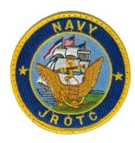**NAVAL JROTC UNIT**

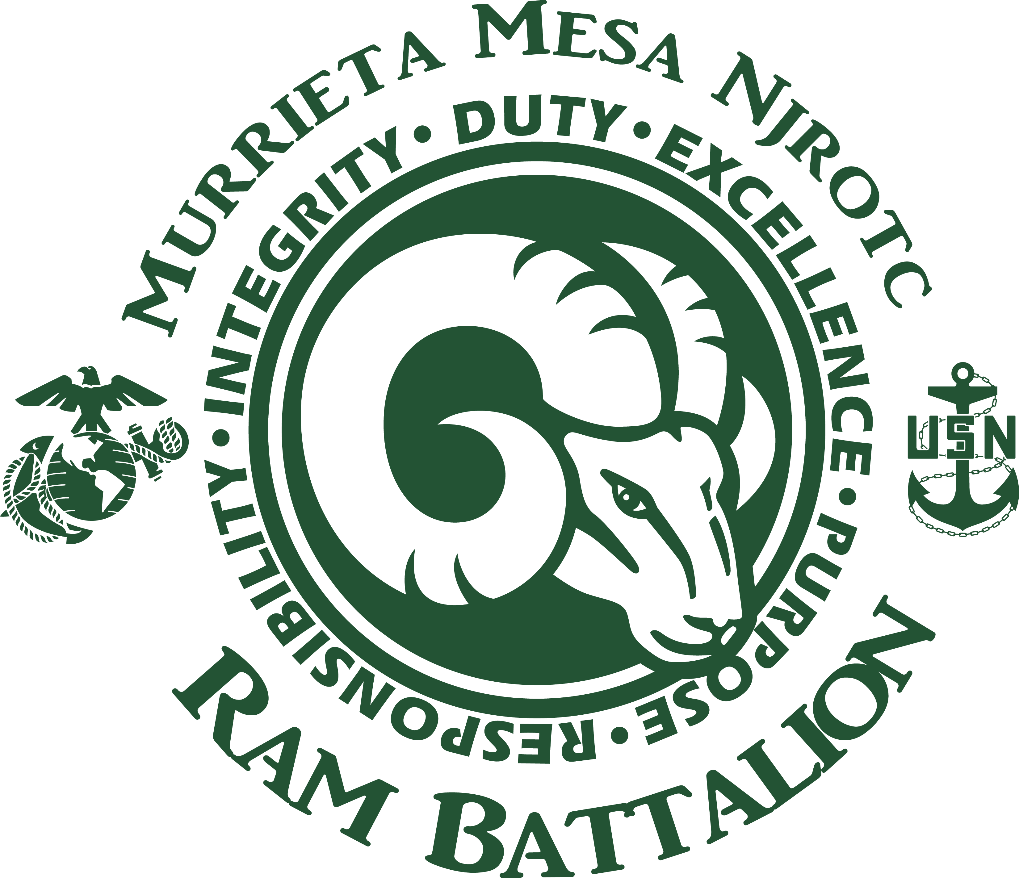

**Murrieta Mesa High School**

**24801 Monroe Ave.**

**Murrieta, CA 92562**

**Tel (951) 677-0568 Ext. 6451**

**Fax (951) 304-1895**

**Syllabus for Naval Science**

**INSTRUCTORS: SNSI -** Lieutenant Colonel Jackson, **NSI** - Chief Meredith

**TYPICAL WEEKLY SCHEDULE:**

**ACADEMICS:** Every Tuesday and Wednesday

**PHYSICAL TRAINING:** Every Thursday and Friday and for the first four weeks on Wednesday

**DRILL:** Every Monday and for the first four weeks on Wednesday

**UNIFORMS/INSPECTIONS:** Will be worn on late start Mondays or when designated by the SNSI. **Inspections will take place on late start Mondays from 0745 - 0835**

***Cadets who do not wear their uniform for THREE (3) or more inspections in a Semester will automatically receive a grade of “F” for Drill and Inspection grade which is 40% of the total grade.***

**COURSE DESCRIPTION:** The purpose of this course is to introduce students to the precepts of citizenship, the elements of leadership, and the value of scholarship in attaining life goals. This course is also designed to engender a sound appreciation for the heritage and traditions of America, with recognition that the historically significant role of sea power will be important in America’s future and develop in each cadet a growing sense of pride in their organization, associates and self. These elements are pursued at a fundamental level.

**PREREQUISITES:** Must have all forms filled out and signed from the **WELCOME PACKET** .

**GOALS**

1. Promote patriotism.

2. Develop informed and responsible citizens.

3. Promote habits of orderliness and precision and to develop respect for constituted authority.

4. Develop a higher degree of personal honor, self-reliance, individual discipline, and leadership.

**OBJECTIVES:** After successfully completing this course, the student will:

1. Exhibit and understanding of the basic naval leadership and followership traits and principles.

2. Understand the basis of our government, the Navy’s mission, and how people support that mission.

3. Expand the understanding and knowledge of Navy ships, their construction, and operation at sea.

4. Demonstrate confidence and proficiency in basic individual, squad, and platoon close order drill.

**EVALUATION CRITERIA**  **GRADING CRITERIA**

# EXAMS = 20% A = 90-100 B = 80-89 C= 70-79

# QUIZES = 20% D = 60-69 F = 0 - 69

# UNIFORM INSPECTIONS = 40% G*rades will always be available at the web site*

# PHYSCIAL TRAINING = 20%

**REQUIRED TEXTBOOKS:** Naval Science 1; NAVEDTRA 37125-C. Cadet Field Manual, NAVEDTRA 37116-H, June 2010, Cadet Reference Manual, 1st Edition July 2010.

**RECOMMENDED REFERENCES and SUGGESTED READING:** The Bluejackets’ Manual, United States Naval Institute, Annapolis, 21st Ed., 1990.

Mack, William P. Vice Admiral USN (Ret), and Connell, Royal W. LCDR USN, Naval Ceremonies, Customs and Traditions, 5th Ed., Naval Institute Press, Annapolis, 1981.

**PRESENTATION**

Lecture and demonstration Small and large group discussions Individual study and research

Reading Guest speakers and Inspectors Field trips

**EXPECTATIONS**

**Class Participation**: Class participation is the life blood of a successful NJROTC program and all students are expected to actively participate in each day’s assignments in the classroom. Students are required to come to class prepared to learn.

**Life Success:** People who are successful in life, who succeed in business, industry, and education often have developed a strong self-discipline, an ability to lead and motivate others, and a well-rounded character. The Navy JROTC program will teach you self-discipline, self-confidence, and leadership skills that can help you successfully meet life's challenges. Our curriculum, instruction, and activities are designed to develop your leadership ability regardless of your career path.

**Leadership:** As a cadet enrolled in the Navy JROTC program you are expected to be a LEADER on and off campus. The best way to lead is by setting the example for others to follow. Your first responsibility is to yourself and your family. Your next responsibility is to your schoolwork, which includes reading and comprehending your assignments prior to class discussion. This will increase your learning abilities and allow for stimulating discussions to enhance what you have read, which should make exam taking a lot easier.

**Note Taking:** Note taking is very important in this class. If you take good notes on what is emphasized in class you will pass the course with high marks. All Cadets should keep a portfolio throughout the year. Recommend a 1” binder with Tabs for the following: handouts, assignments, tests, class notes, unit participation, and the textbooks which are the Introduction and Field Manual. Create a cover page to include your name and period that you’re attending JROTC. The portfolio will be used as extra credit at the end of each Semester.

**Special Discipline Matters**: NJROTC cadets are recognized as leaders on campus and, as such, will conduct themselves in an appropriate manner at all times. Cadets are expected to be on time for each class. The school’s tardy policy will be strictly enforced. In all of their classes and on campus, cadets are expected to be respectful to their teachers, administrators, campus supervisors, and any other member of the Mesa staff. Any incident of misconduct on or off campus will be dealt with by the instructor.

**Uniform Days:** Cadets are required to wear their uniform on inspection days (normally Mondays) and PT gear on Thursday/Friday. *Cadets who attend school and fail to wear their uniform on inspection days and PT days will receive a grade of* ***ZERO****.* *You made that choice when you left your home without your uniform*. Uniform Inspections can be made-up in the same week that was missed on your time before school. All Cadets must wear your uniform all day just as if it were a prescribed uniform day. If you are caught changing clothes during school you will receive a **ZERO**. You get dressed and undressed at home or after school! *Cadets who do not wear their uniform for more than THREE uniform days/inspections in a semester will automatically receive a grade of “F” in drill/inspections (40% of total grade).*

**Promotions/Awards**:Throughout the school year, NJROTC students have the opportunity to earn NJROTC ribbons for outstanding performance in the program. These ribbons are described in detail in the Cadet Field Manual. Students should complete the “Ribbon Request Form” (available in the NJROTC office) and submit it to the instructor via their cadet chain of command. Additionally, all students will be considered for promotion once they have met the requirements for the next rank. These promotions follow the same track as regular Navy promotions. All students will be provided with a copy of the “*Knowledge Handbook”*, which will outline the requirements for promotion.

**Eligibility Requirements:**For a cadet to eligible to participate on a team, or in any extracurricular activity, that cadet must possess a minimum of a 2.00 Grade Point Average (GPA) and be failing no classes. One “F” grade is allowed, but if a cadet has one “F” grade, his/her GPA must be at least 2.25 to be eligible. More than one “F” means the cadet is not eligible, regardless of GPA. Additionally, if a cadet is failing NJROTC class, regardless of GPA, that cadet is not eligible.

**Physical Training Day:** Thursday and Fridays of every week are designated as physical training days, and all students are required to “dress out” for physical training. On Thursday, Physical Training will consist of basic Military style PT, and Fridays will be for organized athletic team sports (Football, Basketball, Soccer, etc.). The uniform for physical training and organized athletics is the Mesa NJROTC green t-shirt, black shorts, and athletic shoes. Should a cadet be unable to participate in physical training, he/she must provide the instructor a doctor’s note or note from the parent stating the reason why (parent notes will be followed-up on). ***Each cadet is required to have a current Health Risk Screening Form***, ***and a Standard Release Form.***

**Textbooks/ Classroom Materials:** To the maximum extent possible the NJROTC program will be paperless. Cadets will be issued Textbooks and will have access to the Cadet Reference Manual and other materials in class. All material that is available in class will be available through the school NJROTC website. If a student does not have internet access at home, a hard copy of the material will be made available for the student to take home.

**Classroom Regulations**:When any student enrolls in NJROTC, he/she is given a Standards of Conduct contract that he/she and the parent must sign. That contract outlines what is expected of each cadet. The basic premise of the program is that NO CADET WILL EVER LIE, CHEAT, OR STEAL, OR TOLERATE ANYONE WHO DOES. ***If any cadet violates this basic premise, he or she is subject to removal from the NJROTC program.*** Once expelled from the NJROTC program, the student cannot return to the program. Proper military decorum will be observed in class at all times. Hats must be removed in the classroom. Upon entering the classroom, all cadets will stand at “PARADE REST” beside their chairs, come to “ATTENTION” when the bell rings, render the appropriate greeting when instructed by the class leader, and recite the “Pledge of Allegiance” and “Cadet Creed” upon cue. Following the unit announcements, cadets will immediately take out their class materials and prepare for the class. Gum chewing is never permitted in class or at any NJROTC setting. Food is allowed in the classroom as long as it does not become distracting. Water bottles are permitted. Sidebar conversations are not allowed. Cadets will be called upon to speak in class. Unless called upon to speak, cadets will remain silent while paying attention to the instructor or whoever has permission to speak. When addressing an instructor, cadet officer, or any other adult on or off campus, the last word out of the cadet’s mouth will be “Sir” or Ma’am”.

**Events:** The Murrieta Mesa NJROTC program does have a few (4-5) events throughout the year that we ask all Cadets to participate in to help support our program. These events are normally held after school or on Saturdays and in most cases the cadets will receive community service hours. It is very important that all Cadets attend these mandatory events. Cadets and parents will be informed of these dates well in advance for proper planning.

**Cadet Leaders**:The NJROTC program is organized similar to that of a regular Navy organization, with cadet leaders assigned based on their rank and experience. Cadet leaders are given a certain amount of authority by the Naval Science Instructors to oversee certain aspects of the program. Cadet leaders represent the Naval Science Instructors and are to be obeyed accordingly. Proper standards of military courtesy and respect are to be followed at all times.

The Murrieta Mesa, Navy JROTC Unit is a disciplined organization and you will be required to adhere to all Unit regulations. We are a Team, and as a Team, we will always **set the example** on and off Campus. First and foremost, you are required to respect those in positions of authority and follow the creed of Honor, Courage, and Commitment.

Michael S. Jackson

Lieutenant Colonel, USMC (Ret)

Senior Naval Science Instructor

**STUDENT:** I____________________________ will obey and follow the Navy JROTC rules and regulations and will give 110% towards improving my self-discipline and academic grades in all classes. I will at the best of my ability maintain a GPA of 2.0 or above with no F’s.

_______________________________

STUDENT SIGNATURE

**PARENTS:** I_____________________________ will encourage my child to wear his/her uniform on inspection days and encourage him/her to succeed in academics. I have read the syllabus and fully support your intentions.

_______________________________

PARENT SIGNATURE